FOUNDRY360

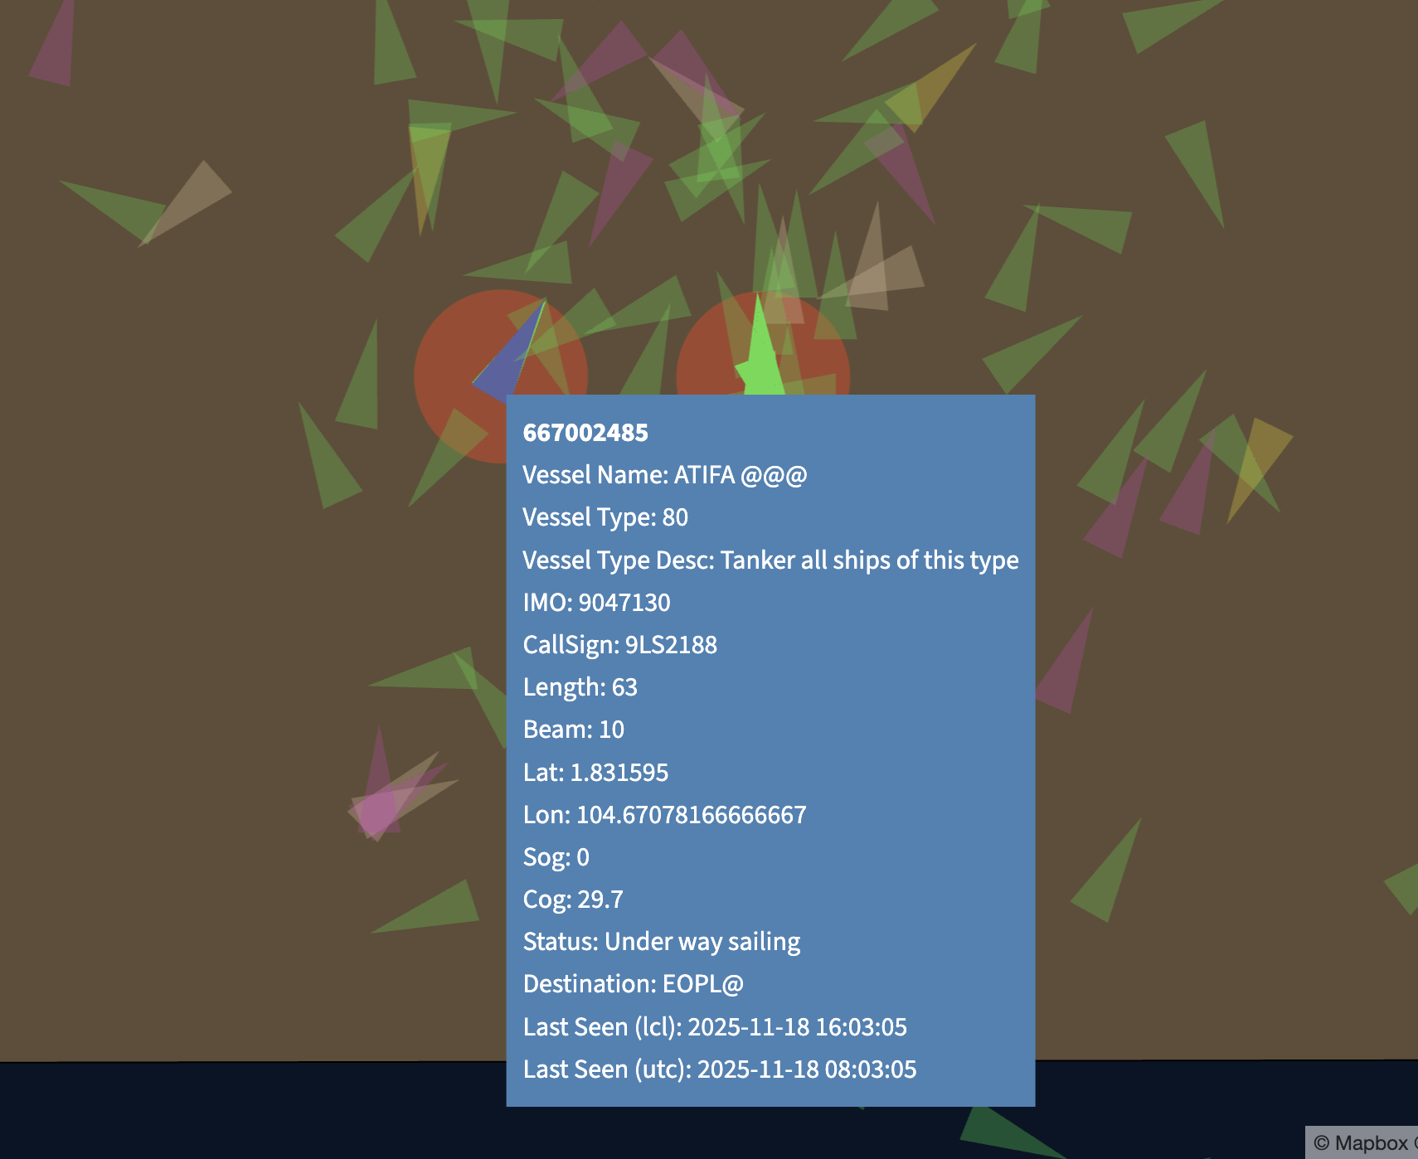

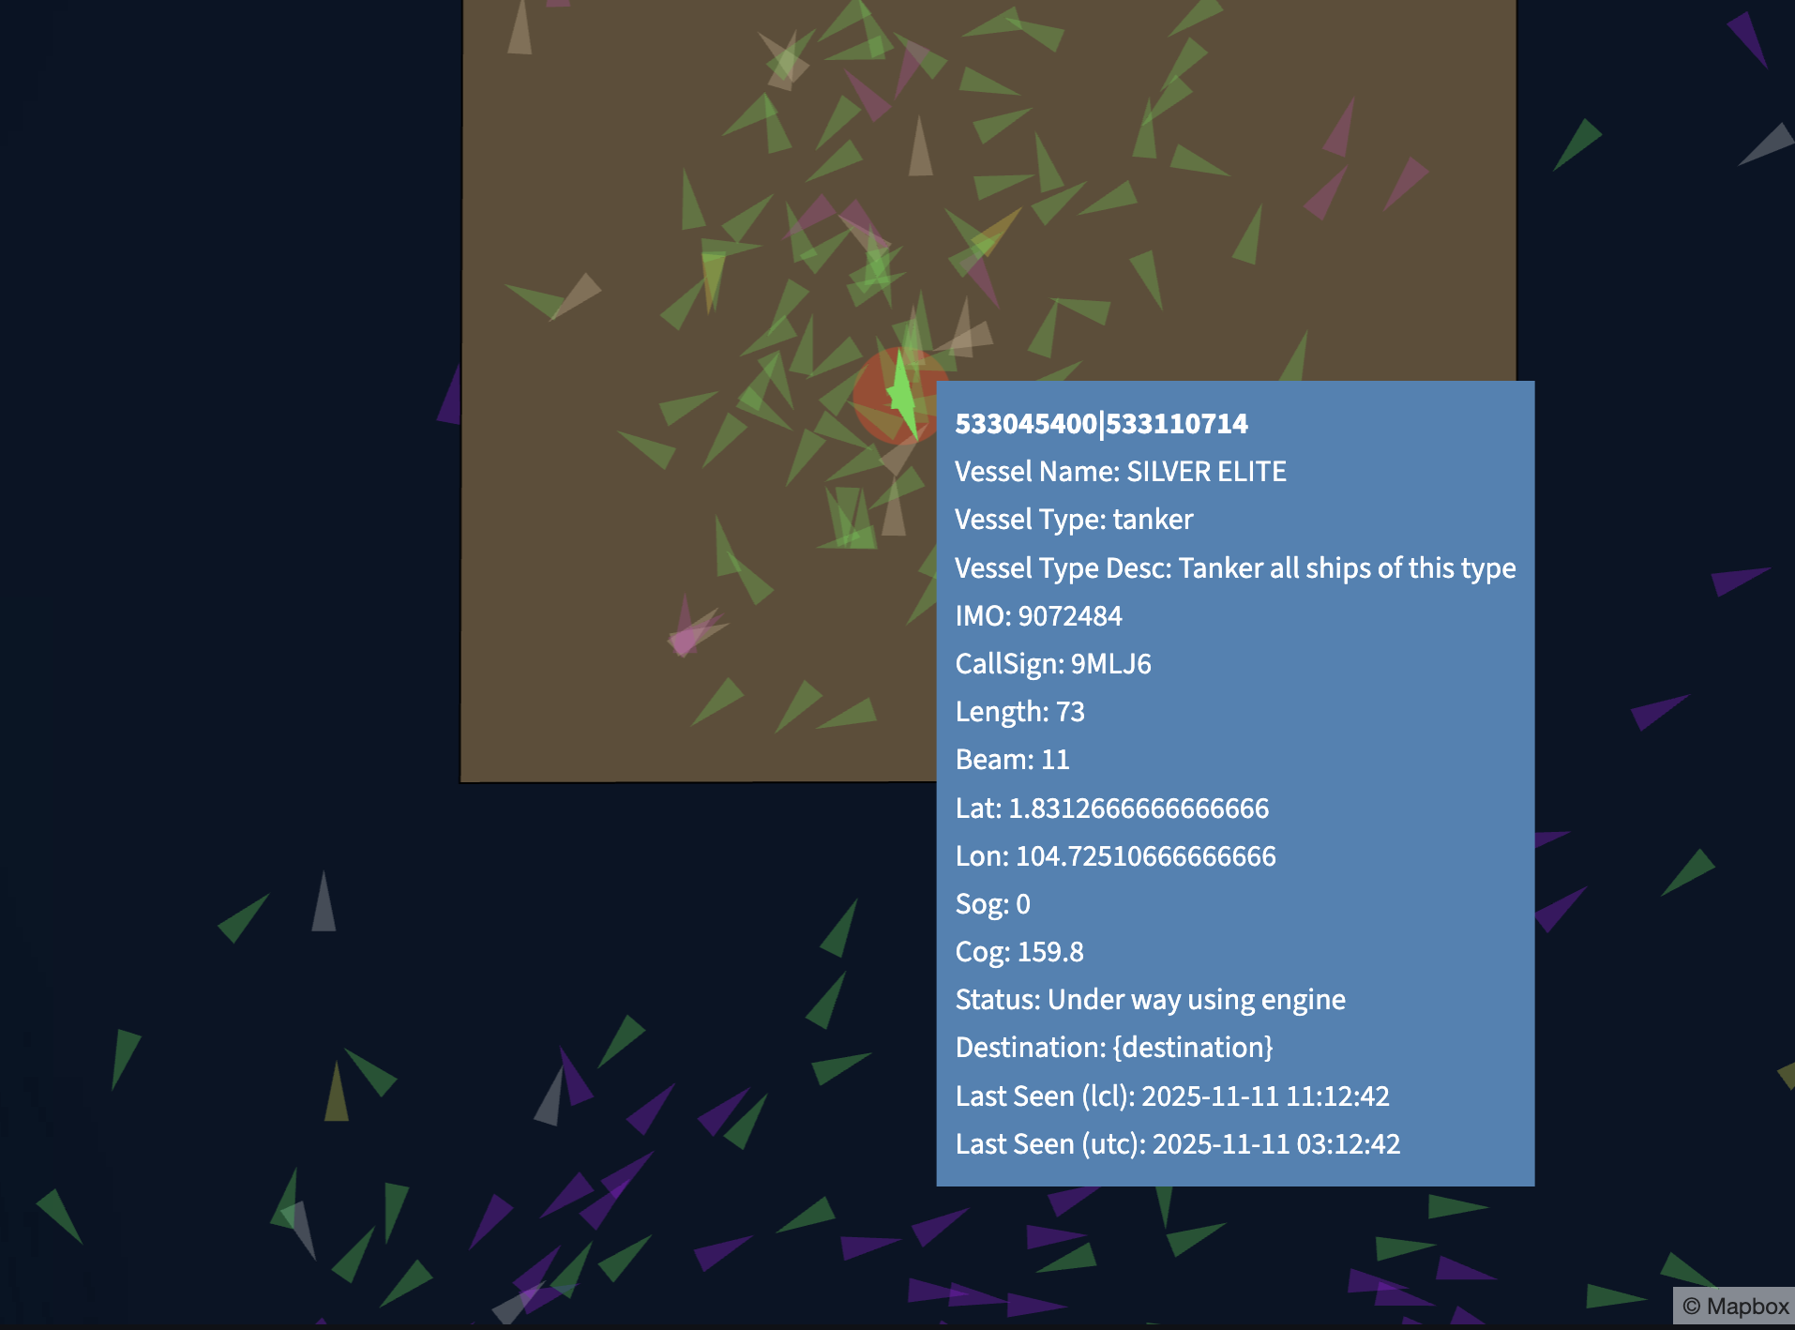

✅ 1. Check AIS Ship Type (Static Data)

Some bunkering vessels transmit a ship type code that hints at their role:

Common AIS Types for Bunker Vessels

AIS Type Meaning Relevance

80 Tanker Many bunker barges send generic “Tanker”

81 Oil tanker Used by small coastal tankers (bunker suppliers)

82–89 Various tanker subclasses Possible bunker roles

52 Tug/Pusher Some bunker barges incorrectly use this

⚠️ Not reliable alone — many bunker barges use generic tanker or “undefined”.

✅ 2. Check AIS Vessel Name Pattern

Most bunkering vessels include keywords in their names, e.g.:

Common naming conventions

“Bunker …”

“… Bunkering”

“… Barge”

“Supply …” / “Fuel Supply”

“Marine Fuel …”

“MT XXX” (Motor Tanker)

Platform logic:

if vessel_name contains ["Bunker", "Bunkering", "Fuel", "Barge", "MT"]: classify as possible bunkering vessel

✅ 3. Check Physical Characteristics (from AIS Static Data)

Bunkering vessels tend to share size profiles:

Typical Bunker Barge Dimensions

Attribute Typical Range

Length 40–110 m

Beam 8–18 m

Draft Shallow, usually 3–6 m

GT 300–3000 GT

Heavier bunker tankers for offshore may be 90–150 m.

Use pattern rules:

IF ship_type in [80–89] AND length < 120m AND draft < 6m:

classify as bunker candidate

✅ 4. Identify Bunkering Operation Behaviour (Dynamic AIS Data)

A. Prolonged side-by-side operations

A bunkering event usually looks like:

Two vessels (usually tanker + client vessel)

Within < 50 meters

Speed 0–0.5 knots

Duration ≥ 1–4 hours

Platform logic:

if two vessels stay < 50m & speed < 0.5kts for > 1 hour:

likely bunkering operation

This is the strongest indicator, used by professional platforms like Lloyd’s List Intelligence, Kpler, Windward, Spire, and eNav.my.

---

B. Loitering at anchorages

Bunker barges typically:

Stay at main anchorages

Move between anchorages and jetty supply terminals

Rarely perform port-to-port voyages

Look for:

Frequent stops at designated bunkering anchorages (e.g., Singapore OPL, Pengerang, Langkawi, Labuan, Fujairah)

---

✅ 5. Check Destination & Navigational Status

Bunker vessels often report:

Destination strings

“BUNKERING”

“SUPPLY”

“STANDBY”

“WAITTING”

“OPL”

“ANCHORAGE”

“FUJAIRAH ANCH”

“SINGAPORE ANCH”

“PENGERANG”

Navigational Status

At Anchor (5)

Not Under Command (7)

Engaged in Special Operations (9)

---

✅ 6. Check Historical Routes

Bunker vessels typically:

Move repeatedly between fuel terminals, refineries, and anchorages

Do short, repetitive trips

Examples in Malaysia:

Pengerang → OPL → Pengerang

Labuan → OPL → Labuan

Port Klang → PKPS Jetty → Westport Anchorage

---

✅ 7. Check MMSI/Registry Information

A bunkering fleet can be identified from:

A. MMSI block

Singapore (563xxx)

Malaysia (533xxx / 548xxx)

UAE (470xxx)

B. Vessel Class Records

Some bunkering fleets are registered in:

MOMPA (Malaysia)

MPA (Singapore)

Fujairah Port

These often list service type: Bunkering / Oil Barge.

---

✅ 8. Check External Databases

Cross-check AIS identity with databases like:

IHS / Equasis

MarineTraffic

Lloyd’s List Intelligence

Kpler

eNav.my internal registry (if configured)

These often label vessels as:

Oil Bunker

Fuel Barge

Bunkering Tanker

---

⚓ 9. Combining All Methods (Recommended VTMS/MarineAI Logic)

MarineAI-style classification algorithm

bunker_score = 0

if ship_type in tanker types: bunker_score += 1

if "bunker" in name or "fuel" in name: bunker_score += 2

if length < 120 and draft < 6m: bunker_score += 1

if at anchorage and repeating pattern: bunker_score += 1

if prolonged side-by-side ops detected: bunker_score += 3

if destination indicates bunkering: bunker_score += 1

if bunker_score >= 4:

classify as Bunkering Vessel

This gives >90% accuracy based on real AIS analytics.

---

✅ If you want, I can prepare:

✔ A flowchart to classify bunkering vessels

✔ A Python script to detect bunkering operations using AIS logs

✔ A technical explanation for VTMS tender documentation

✔ A MarineAI/eNav.my algorithm module for bunkering detection

Vessel with different MMSI but same IMO

